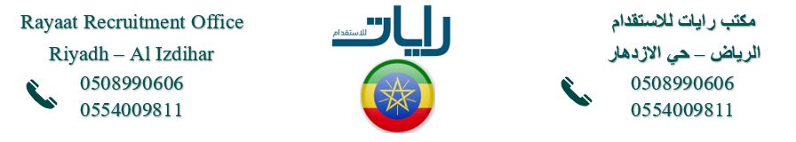
Full Body Picture
معلومات شخصية Information Personal
Nationality | ETHIOPIA |  | اﻟﺟﻧﺳﯾﺔ
Date of Birth | 31 OCT 01 |  | ﺗﺎرﯾﺦ اﻟﻣﯾﻼد
Address | DEBRE BIRHAN |  | اﻟﻌﻧوان
Marital Status | SINGLE |  | اﻟﺣﺎﻟﺔ اﻻﺟﺗﻣﺎﻋﯾﺔ
No. of Children | 0 |  | ﻋدد اﻷطﻔﺎل
Height/Weight | 160CM | 52KG | اﻟوزن واﻟطول
Education Qualifications | HIGH SCHOOL |  | اﻟﻣﺳﺗوى اﻟﺗﻌﻠﯾﻣﻲ
Tel. Number | +2519 |  | رﻗم اﻟﺗواﺻل

خبرات سابقة Experience Overseas
Country | Period | Date
 |  | N/A

المهارات Skills
Cooking | NO | اﻟطبﺦ | Baby  Sitting |  | اﻟﺗﻌﺎﻣل ﻣع اﻷطﻔﺎل
Washing |  | اﻟغﺳﯾل | Sewing | NO | اﻟﺧﯾﺎطﺔ
Cleaning |  | اﻟﺗﻧظﯾف | Driving | NO | ﺳﺎئق

Languages |  | اﻟﻠغﺎت
اﻹﻧﺟﻠﯾزﯾﺔ English |  | Arabic | اﻟﻌربﯾﺔ
Good |  | NO | ﺟﯾد
Fluent |  | NO | ﻣﻣﺗﺎز
NO

 | Reference Number
 | Full Name | ABERASH TSEGAYE GIZA | اﻻﺳم
 | Religion | NON-MUSLIM | اﻟدﯾﺎﻧﺔ
 | Position Desired | HOUSEMAID | اﻟوظﯾﻔﺔ
 | Salary | 1000SR | اﻟراﺗب
 | Age | 24 | اﻟﻌﻣر
 | Sex | FEMALE | اﻟﺟﻧس

معلومات الجواز Information Passport
Number | EQ1235694
Issue Date | 30 NOV 24 | اﻹﺻدار
Expiry Date | 29 NOV 29 | اﻻﻧﺗﮭﺎء
Issue place | ETHIOPIA | اﻹﺻدار
Next of Kin name |  | ﺧص
Next of Kin | +2519 | ﻘرﯾب
number

Remarks: SHE IS HARDWORKING, NEAT, ORGANISED, SMART, DISCIPLINED, CARING, HAS A GOOD ATTITUDE, SPEAKS GOOD ENGLISH AND LOVES TAKING CARE OF CHILDREN.

